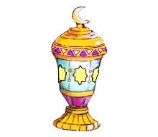

Ramadan word search

Name----------- Date------------

|  |  |  |  |  |  |  |  |  |  |  |  |  |
| --- | --- | --- | --- | --- | --- | --- | --- | --- | --- | --- | --- | --- |
| K | K | P | P | M | M | I | L | S | U | M | E | R |
| R | S | W | R | E | Y | A | R | P | E | U | E | A |
| F | F | I | B | Y | L | I | M | A | F | H | F | M |
| D | R | S | D | U | H | T | Y | D | A | A | W | A |
| P | I | H | S | R | O | W | G | G | S | M | D | D |
| U | E | A | S | O | L | R | R | A | T | M | I | A |
| M | N | R | D | O | F | Q | Q | B | I | A | J | N |
| M | D | E | R | R | V | O | O | S | N | D | G | L |
| A | S | G | N | A | R | U | U | E | G | E | F | Y |
| H | Y | T | I | R | A | H | H | M | A | L | S | I |

*Word Bank*

Islam worship friends Quran

Ramadan fasting share Charity

Prayer family Muslim Muhammad